Asia-China-Jade-Western Zhou 900-700 BCE-Figurine

Standing male figure carved in the round from semi-translucent white nephrite jade ca. 7.1 cm. high, 2.5 cm. wide). The elaborate bilateral design on the skirt is reminiscent of the bird tail feather plume on a Shang kneeling man, fig. 2. Also, this figure is iconographically comparable to the examples in the Minneapolis Institute of Arts and in the British Museum in its headdress design and the position of the held hands. The headdress on the present example also is geometrically similar to the Shang figure's bird tail feather plume and this figure also appears to have animal ears extending from either temple. Perhaps this figure is another manifestation of a Chinese Wu or shaman in the process of transformation into a spiritual animal/bird. In addition to being a symbol of luxury and wealth, jade is associated with the qualities of purity and refinement and is often believed to possess magical powers, which would be consistent with the description of this individual as a spiritual leader..

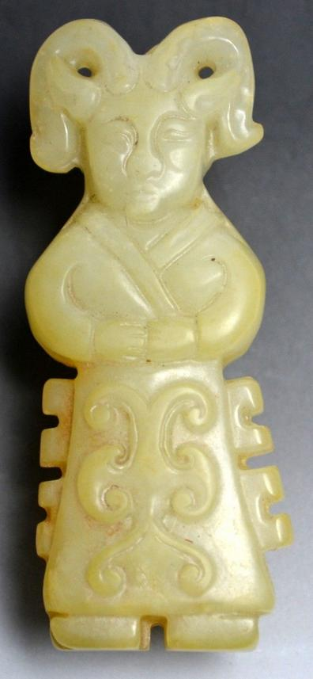 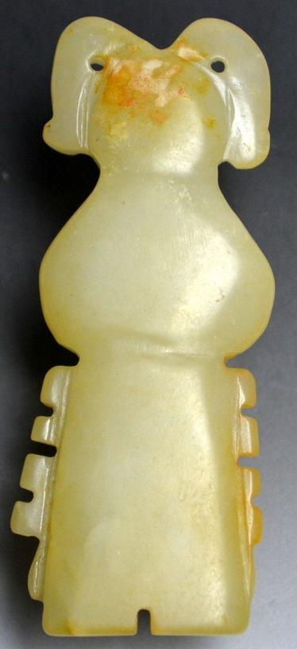

Fig. 1-2. Western Zhou 900-700 BCE Jade Figurine.

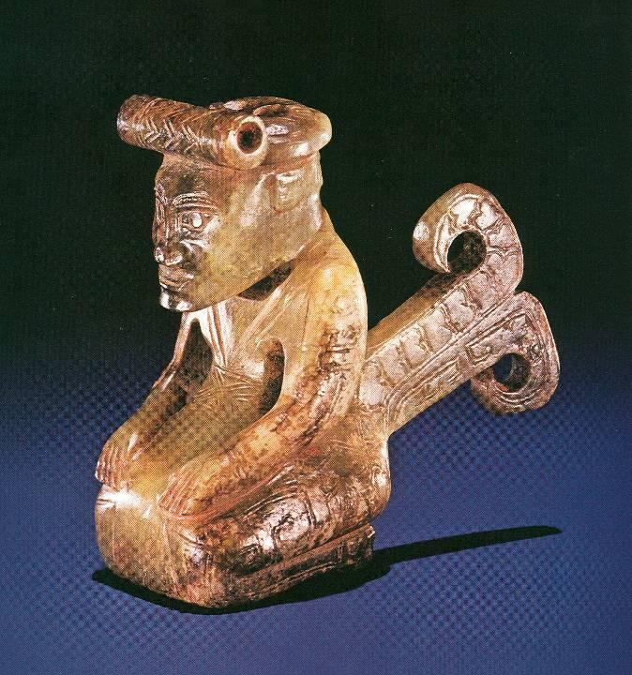

Fig. 3. Jade male kneeling figure Henan Province, Shang Dynasty, about 1000 BCE with staring eyes as if in a trance that may signify his being a shaman or Wu. He has a broad nose and wears a long robe with a wide sash at the waist as in the white jade figurine above and has a stylized bird feather plume extending from his back that may signify his taking spiritual flight. From *Zhongguo meishu quanji, Diaosu bian,  1* (Beijing: renmin meishu chubanshe, 1988), p. 26.

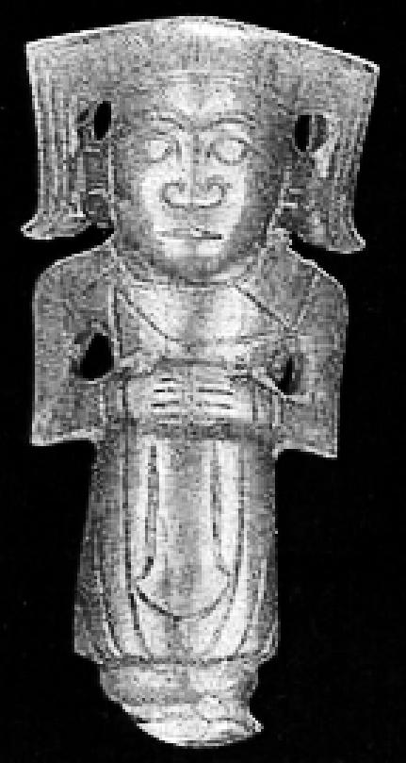 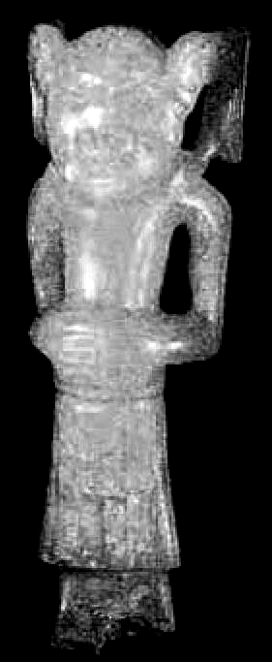

Left: Jade male figure (H. 6.5 cm.) in the Minneapolis Institute of Arts. Late W .Zhou (c.700 BC). From http://www.greecetravel.com/archaeology/mitsopoulou/zulu/p091pic02.jpg. Right: Early Zhou (10th c.BC) jade figures (7 cm.) in the British Museum.

